**Herguan University**

**CS565 - .NET Programing - *fall – 2015***

***Prof: Wiselin Mathuram***

**Report –** Read and write Database

**Name: VijayPrakash.Mallipeddi**

**STID: 142061**

**Required Tools:**

* Visual Studio (2010 and UP)
* SQL Server (I’m using SQL Server 2008R2 )
* Database (For Sample Data)

**Step1:**

**Creating a Sample Registration Table**

Create Database Student

Go

CREATE TABLE Registration(

FName Varchar(9),

LName Varchar(9)

);

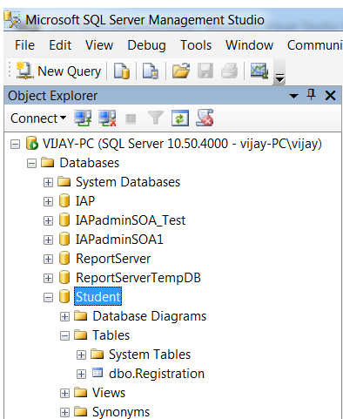

**Step2:**

**Creating Connection to database from Visual Studio**

Connect to database through Data Source Configuration Wizard.

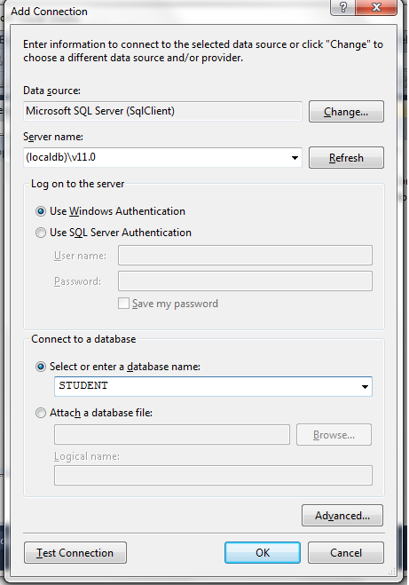

**Step3:**

**Create New Project in visual studio**

Create the web form for displaying student data. Right-click your project, and Add a New Item. Select the Web Form, and name it Students.aspx.

Two text box **FName& LName** and a Submit button.

Below is the code used to run in SUBMIT button.

Imports System.Data.SqlClient

Public Class Form1

Private Sub Form1_Load(sender As Object, e As EventArgs) Handles MyBase.Load

'TODO: This line of code loads data into the 'STUDENTDataSet.REGISTRATION' table. You can move, or remove it, as needed.

Me.REGISTRATIONTableAdapter.Fill(Me.STUDENTDataSet.REGISTRATION)

End Sub

Private Sub Label2_Click(sender As Object, e As EventArgs) Handles Label2.Click

End Sub

Private Sub Button1_Click(sender As Object, e As EventArgs) Handles Button1.Click

Dim connectionString As String = "Data Source= Vijay-pc; Initial Catalog = STUDENT;Integrated Security=true“

Dim queryString As String = "INSERT INTO REGISTRATION (FName, LName) values (@FName,@LName)“

Try

Using connection As New SqlConnection(connectionString)

connection.Open()

Dim command As New SqlCommand(queryString, connection)

command.Parameters.AddWithValue("@FName", TextBox1.Text)

command.Parameters.AddWithValue("@LName", TextBox2.Text)

command.ExecuteNonQuery()

End Using

Catch ex As Exception

MsgBox("Exception : " + ex.ToString)

End Try

End Sub

Private Sub TextBox1_TextChanged(sender As Object, e As EventArgs) Handles TextBox1.TextChanged

End Sub

Private Sub DataGridView1_Cell ContentClick(sender As Object, e As DataGridViewCellEventArgs) Handles DataGridView1.CellContentClick Gridview.DataBind()

End Sub

End Class

**Output:**

